**Security Scan Remediation for FAS**

Release 5.4

3/6/18

DHS Systems Engineering

Life Cycle

**Transportation Security Administration**

Revision History

|  |  |  |  |
| --- | --- | --- | --- |
| **Date** | **Version** | **Description** | **Author** |
| 3/6/18 | 1.0 | Initial Document | Tracy Ho |

Table of Contents

1. Overview 4

2. Details of different functionality 4

2.1 Struts Upgrade 4

2.2 JDK Upgrade 5

2.3 Return Inactive IACMS STA associations 5

2.4 Security-Related Fixes 10

2.4.1 Configuration settings (CM-6) Body parameters accepted in query 10

2.4.2 Input Validation Cross Site Forgery 11

2.5 508 Compliance Related Fixes 12

2.5.1 508 remediation – Keyboard accessibility 12

2.5.2 508 remediation – Web form 13

# 

# **Overview**

The purpose of this document is to describe the release highlights for FAS Release 5.4.

# Details of different functionality

## Struts Upgrade

*Finding:* To address security concerns, current version of Struts used in FAS needs to be upgraded to latest version 2.5.14.1

*Summary Description:* Removed all struts2 2.5.13 jar files and dependencies and upgraded to version struts2 2.5.14.1

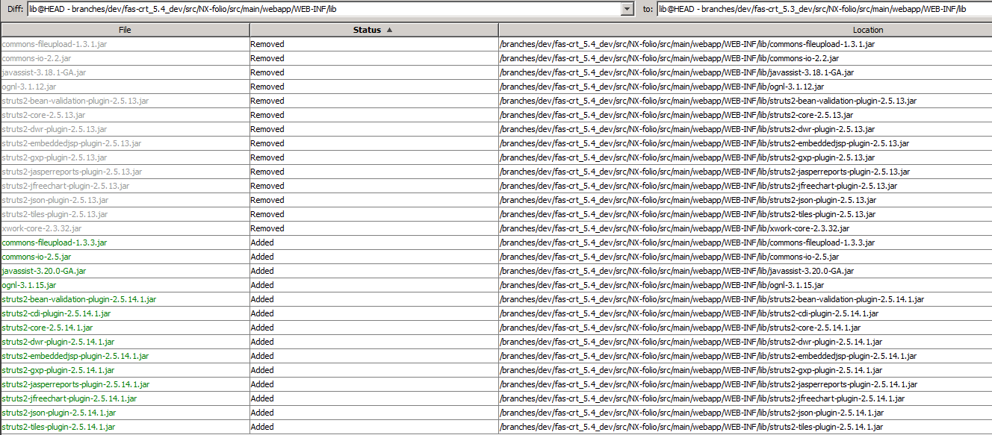

## JDK Upgrade

*Finding:* To address security concerns, current version of JDK used in FAS needs to be upgraded to latest version 8u162

*Summary Description:* JDK 8u162 are upgraded in both DEV servers

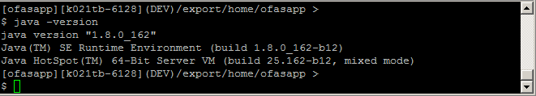

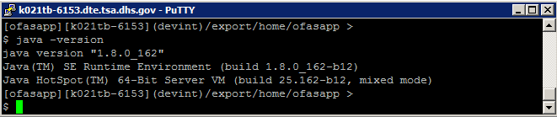

## Return Inactive IACMS STA associations

*Finding:* To address the inactive STA pulled issues.

*Summary Description:* Tuned up the fas_subject_individual_body.sql query

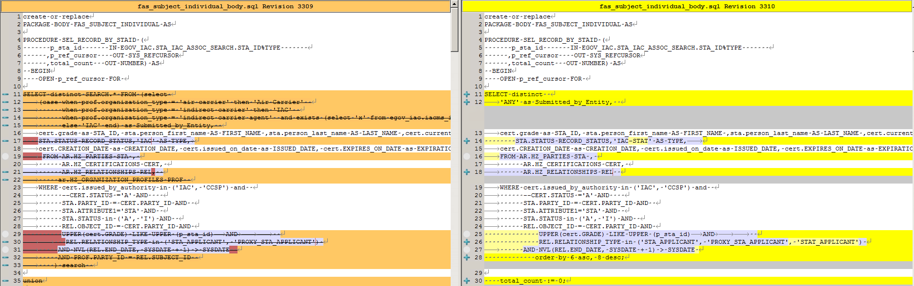

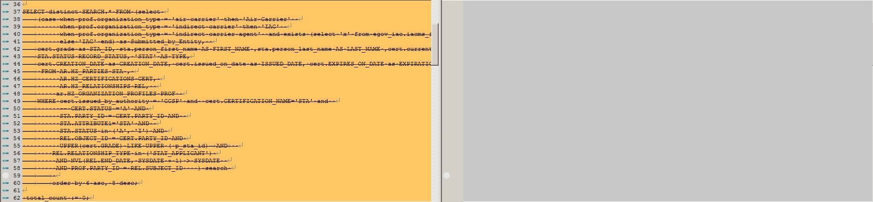

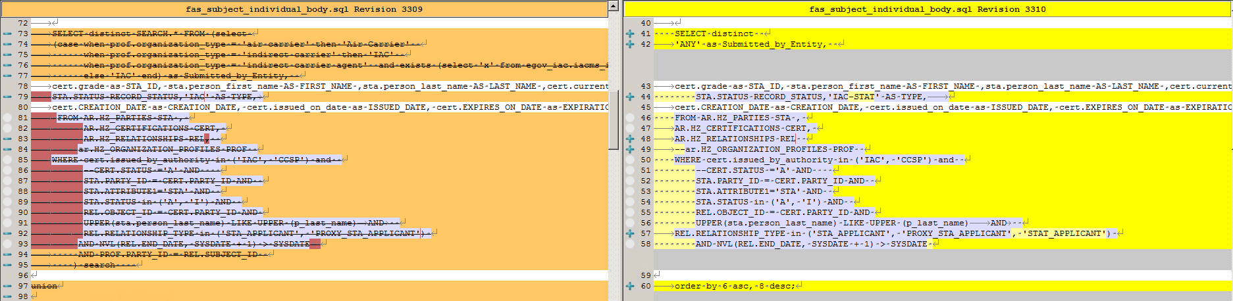

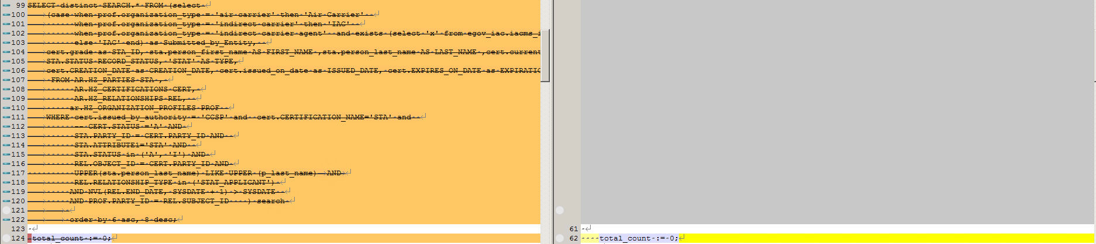

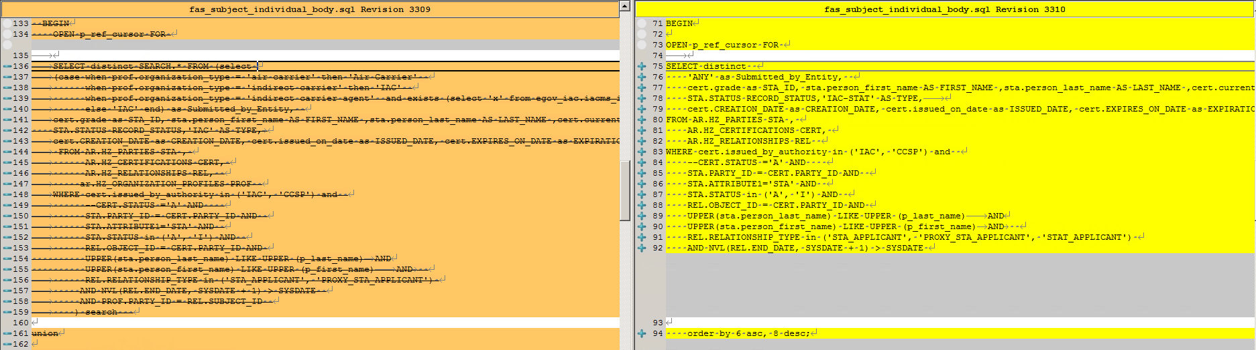

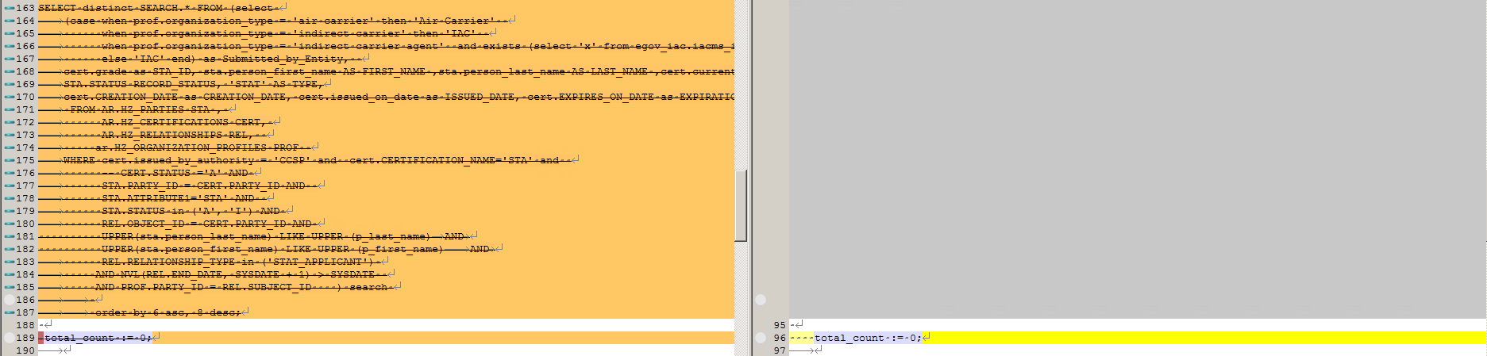

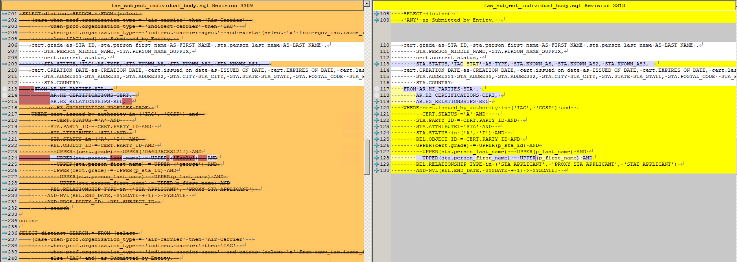

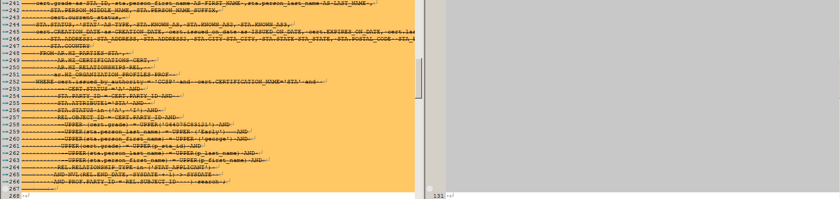

## Security-Related Fixes

### Configuration settings (CM-6) Body parameters accepted in query

*Finding*: Application processed body parameters that were submitted in the query.

*Summary Description:* Use prepareStatement instead of createStatement. The prepareStatement can bind the parameters to avoid the sql injection.

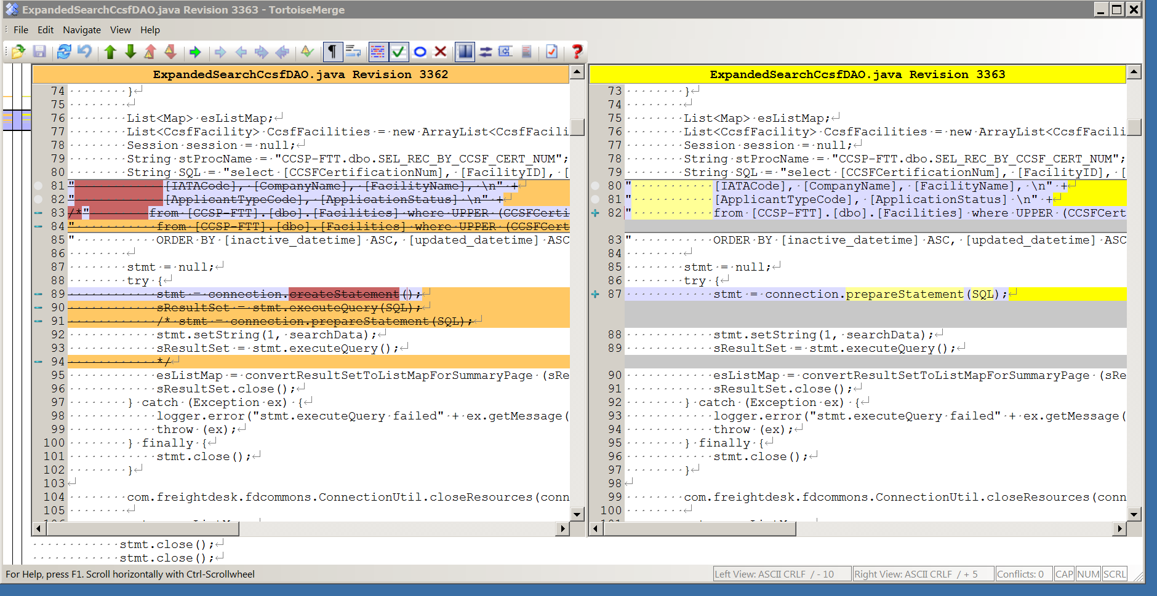

### Input Validation Cross Site Forgery

*Finding:* Cross-site request forgery (CSRF) is a type of website exploit carried out by issuing unauthorized commands from a trusted website user. CSRF exploits a website’s trust for a particular user's browser, as opposed to cross-site scripting, which exploits the user’s trust for a website. This term is also known as session riding or a one-click attack.

*Summary Description:* The predefined CSRF_TOKEN value is validated in the vulnerable code to ensure the inputs are originated from legitimate pages.

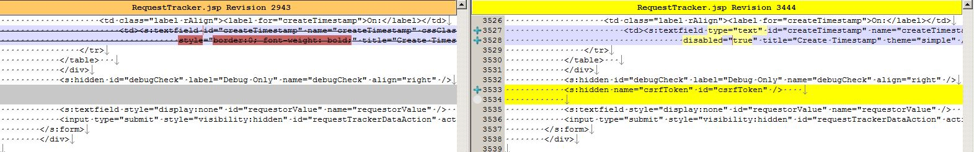

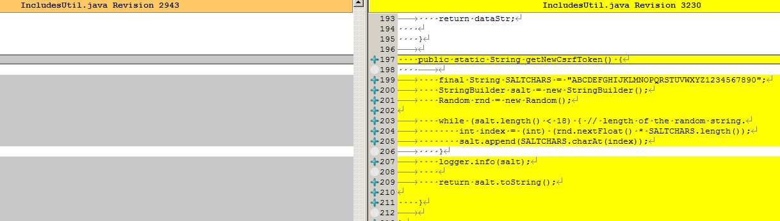

## 508 Compliance Related Fixes

### 508 remediation – Keyboard accessibility

*Finding:* An interactive element or function cannot be accessed or activated by keyboard

*Summary Description:* Added scope=col and scope=row tags to <th> and <td> in all tables

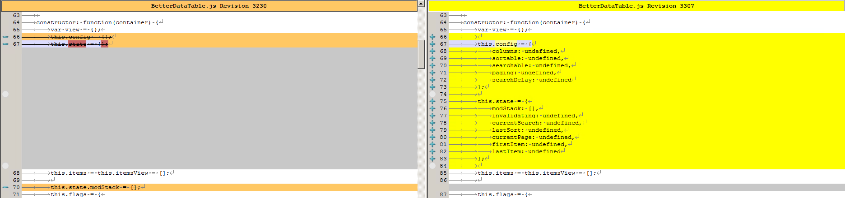

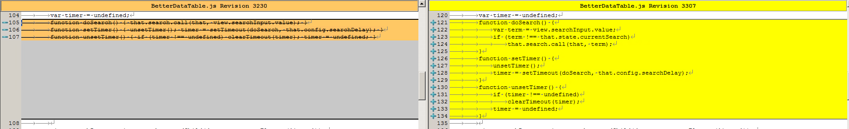



### 508 remediation – Web form

*Finding:* Data table’s row or column headers have to be identified programmatically.

*Summary Description:* Added scope=col and scope=row tags to <th> and <td> in all tables